Method:

1. We used the command “ $f_{new_1}$ = medfilt2(f1, [3 3]);” to filter the two images. The operation is a 3 by 3 median filter where the output $f_{new_1}\left(x,y\right)=median value\left\{f(m,n)\right.\} and \left(m,n\right)∈N\left(x,y\right)$; N(x, y) is the 3 by 3 filter. Then we use the algorithm that we derived in project 4 to compute and plot the histogram of the image.

Results:

Original “proj5.gif” image

Original “proj5.gif” image’s histogram

From the figure, we see that the original “proj5.gif” image only has two pixel-values, which is what we expected sine there are only a white background and a dark foreground; the white background has one uniform pixel value and the dark foreground has one uniform pixel value.

Result “proj5.gif” image after applying a 3X3 median filter

As we can see from the figure, all the thin grids on the original image are removed but the two line-streaks remained. In addition, the letters in the original image are distorted as well.

Filtered “proj5.gif” image’s histogram

From the figure, we see that the histogram does not change much compared to that of the original image because we did not change the image much except that we removed the thin grids. Thus, the two pixel-values should remain the same but the numbers of pixels for dark foreground decreased a little bit.

Original “Wheelpepper.gif” image

Original “Wheelpepper.gif” image’s histogram

From the histogram plot, we see that all the pixel values lie to the left side of the horizontal axis, which is what we expected since the image is dim. We can also see there are some white and black pixels on the far left and far right; those are the pepper noises in the original image.

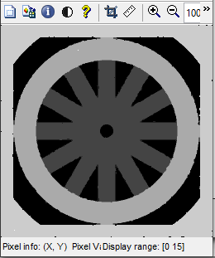

Result “Wheelpepper.gif” image after applying a 3X3 median filter

From the figure, we see that nearly all the pepper noises are filtered out by the median filter. However, the image is also distorted a little bit compared to the original image.

Filtered “Wheelpepper.gif” image’s histogram

From the histogram plot, we see that a great number of white pixels and black pixels are removed; this is due to the removal of pepper noises in the original image.

With all the observations described above, we can conclude that the median filter does improve the image even though it is not perfect. We see that the thin grids in the proj5.gif image and pepper noises in the wheelpepper.gif image are nearly entirely removed; however, the image is also distorted a little bit by the filtering.